TestRail
Session 1 – Foundations + Core Hands-On
Day 1: TestRail Basics & Positioning
Learnt
- What TestRail is and why companies use it
TestRail is a test management tool used to:
- Design test cases
- Organize them by feature/module
- Execute tests for releases/sprints
- Track results and quality metrics
- Provide audit-ready test evidence (very important for Veeva)
- TestRail vs Xray vs Jira (high-level)
- Where TestRail fits in Agile testing
- Core terminology:
  - Project
  - Test Suite
  - Test Case
  - Test Run
  - Test Plan
Practical
- Logged into TestRail
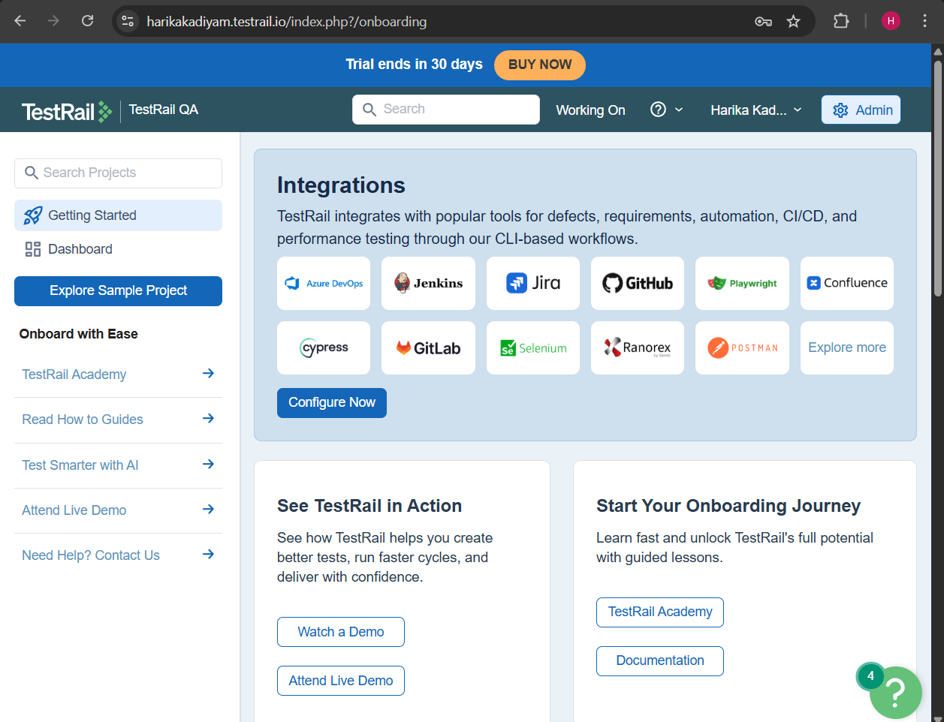
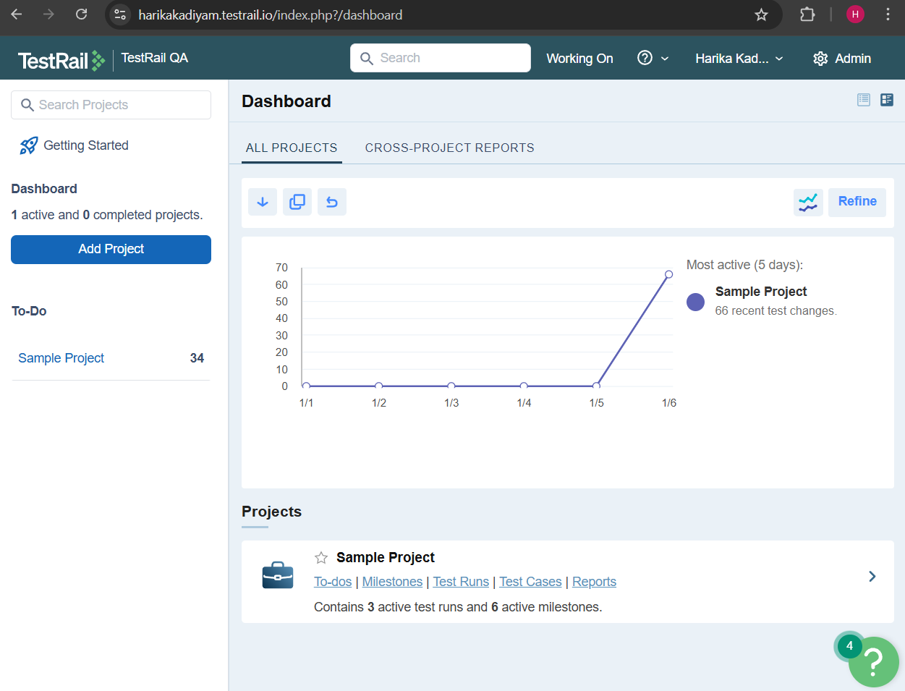
- Created a Project
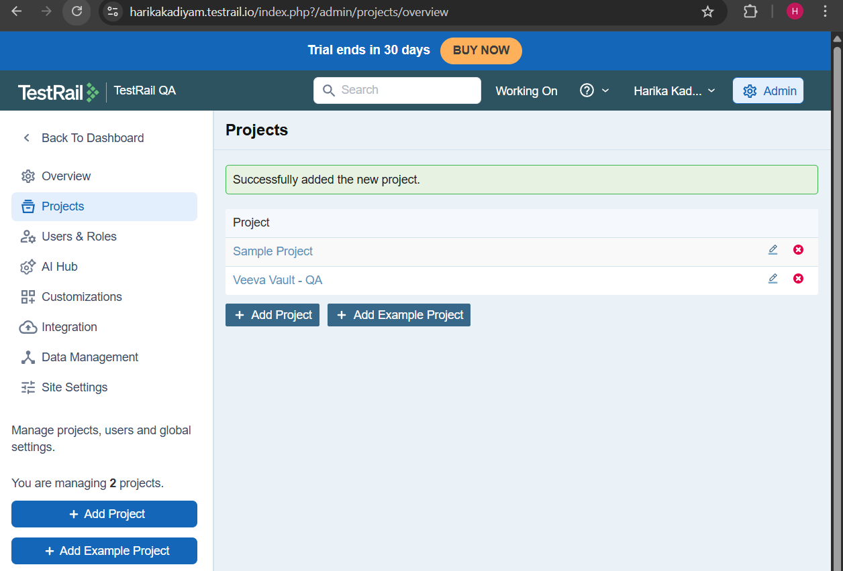
- Chose project type:
  - Single Repository (preferred)
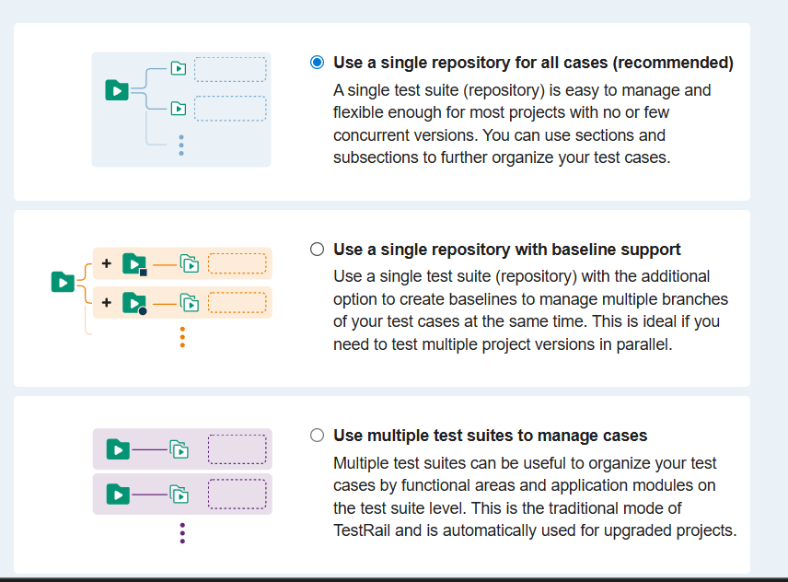
- Explored:
  - Dashboard
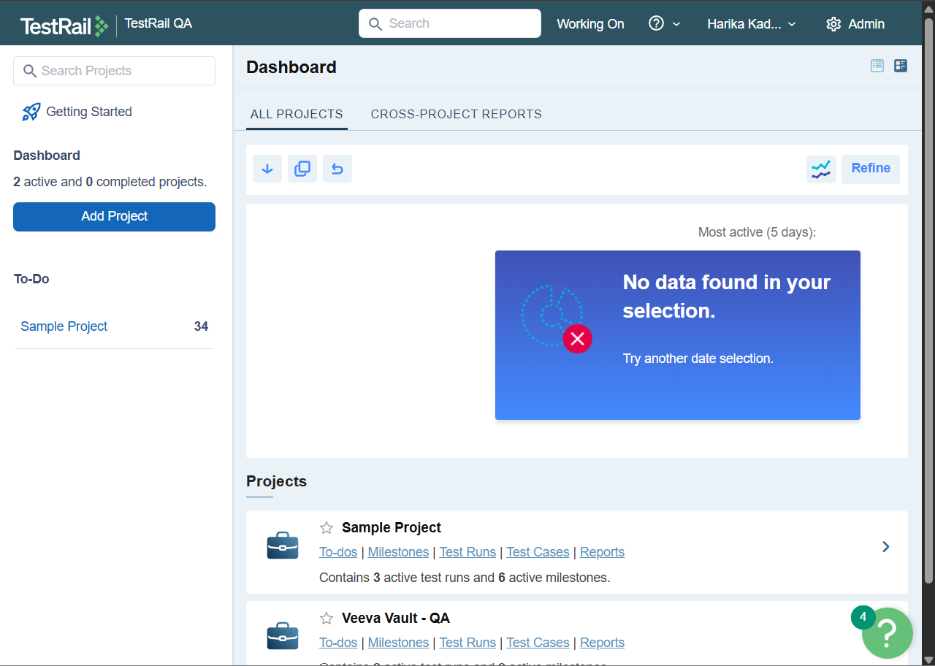
  - Test Cases
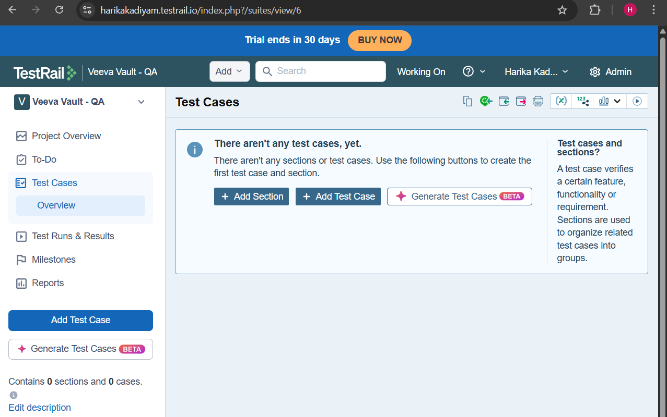
  - Test Runs & Results
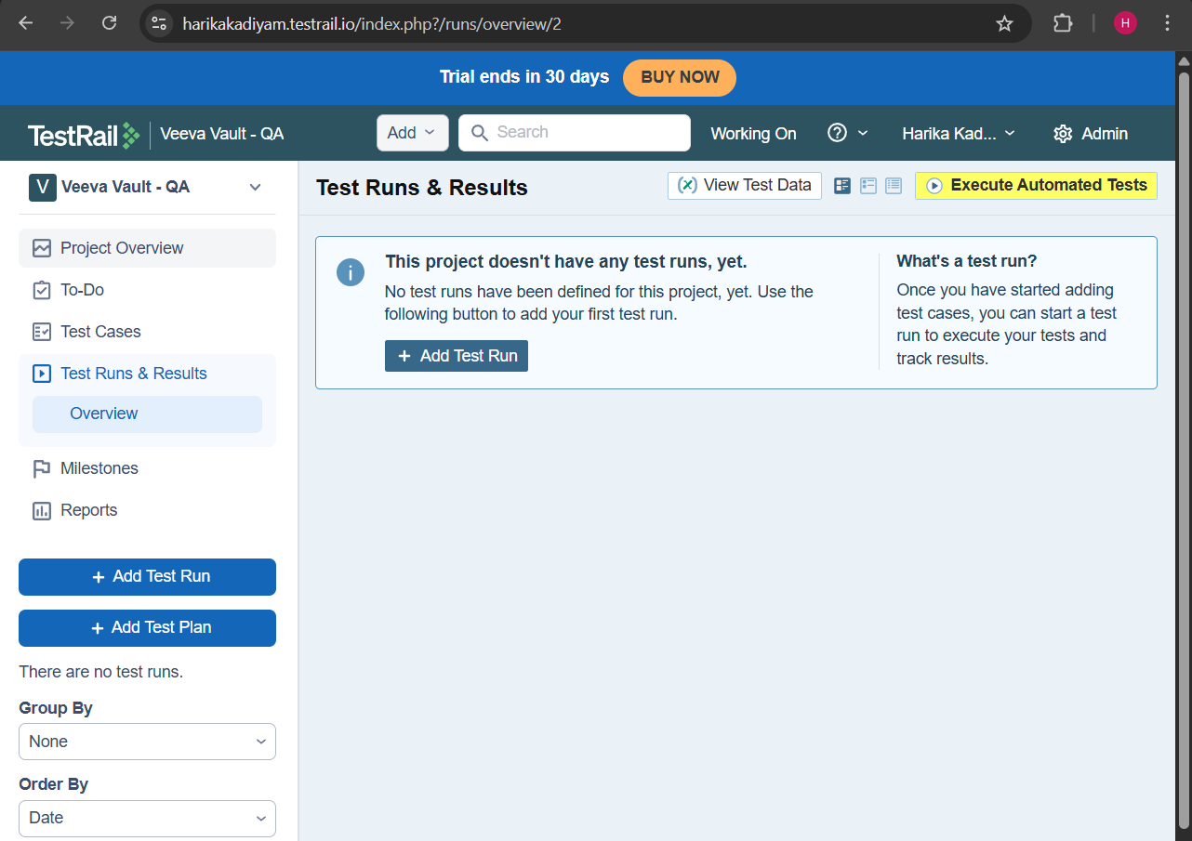

Day 2 : Test Suites & Test Case Design
Learnt
- Test Suite structure
  - In Single Repository mode, TestRail has one default Test Suite.
  - This suite contains all test cases for the application.
  - Think of it as:
Application → Test Suite → Sections → Test Cases
Example:
Veeva Vault – QA (Project)
└── Test Suite (Single Repository)
├── Login
├── User Management
├── Document Management
├── Workflows
├── Security & Access Control
- Section-based organization
A Section is a logical grouping of related test cases, usually by:
- Feature
- Module
- Functional area
- Test case fields:
  - Preconditions
  - Steps
  - Expected Results
  - Priority, Type
Practical
- Created Test Suites:
  - Login
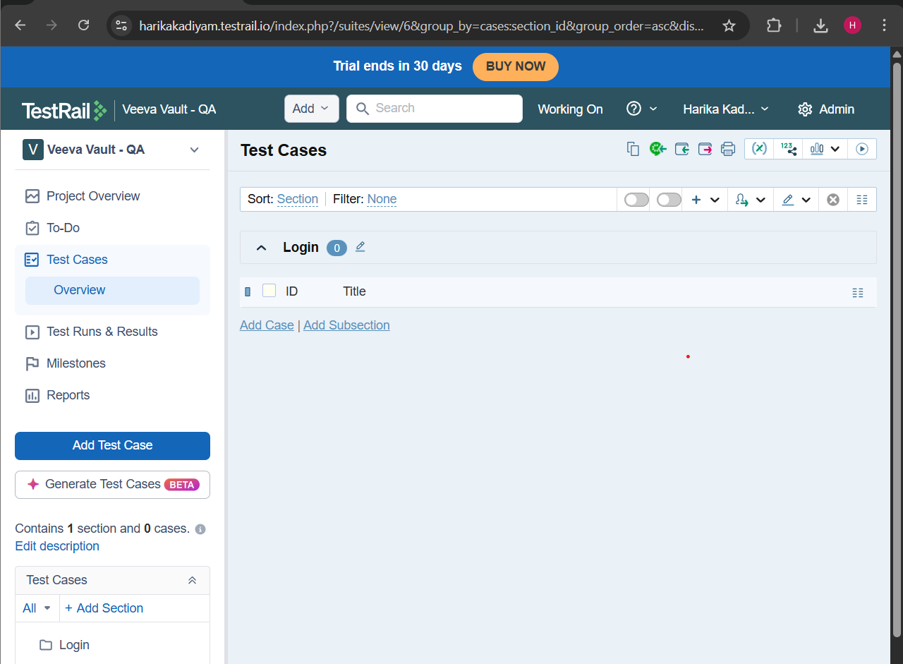
  - User Management
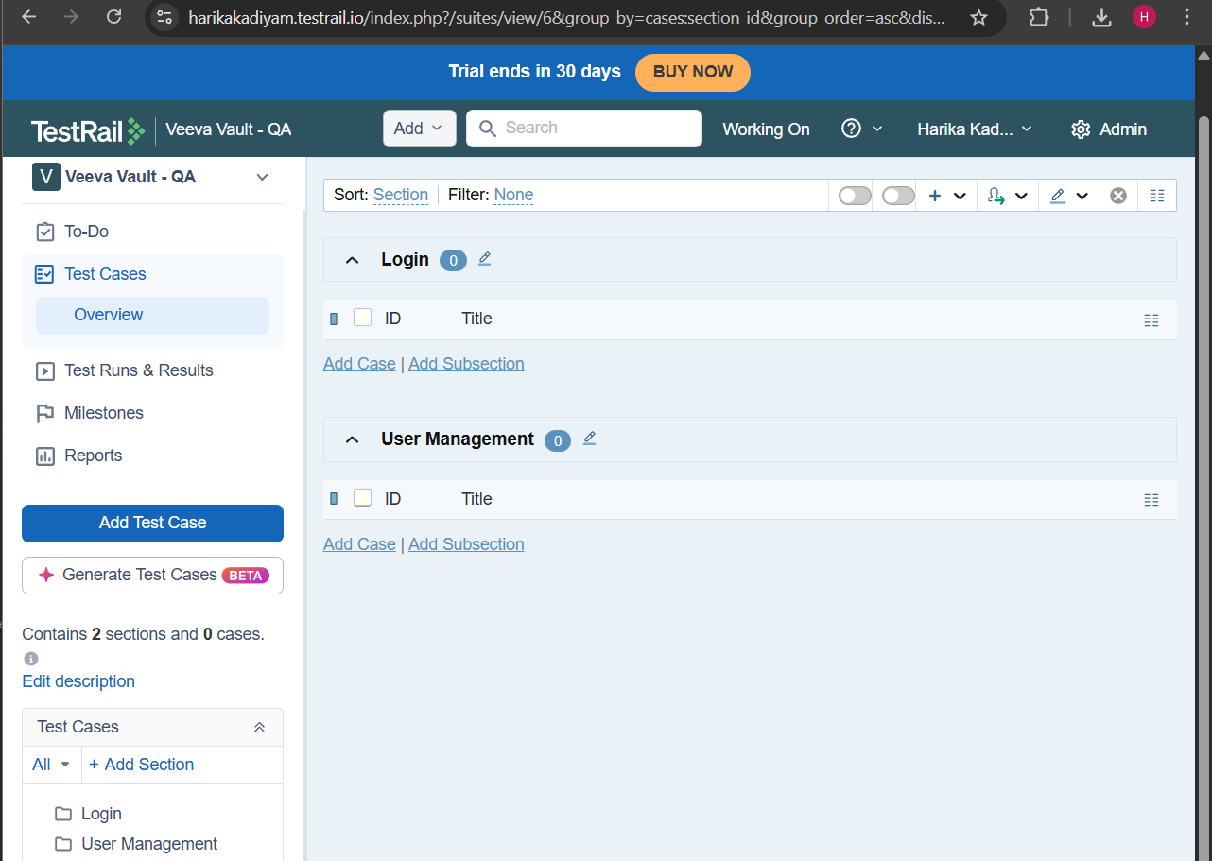
- Created 8 manual test cases each
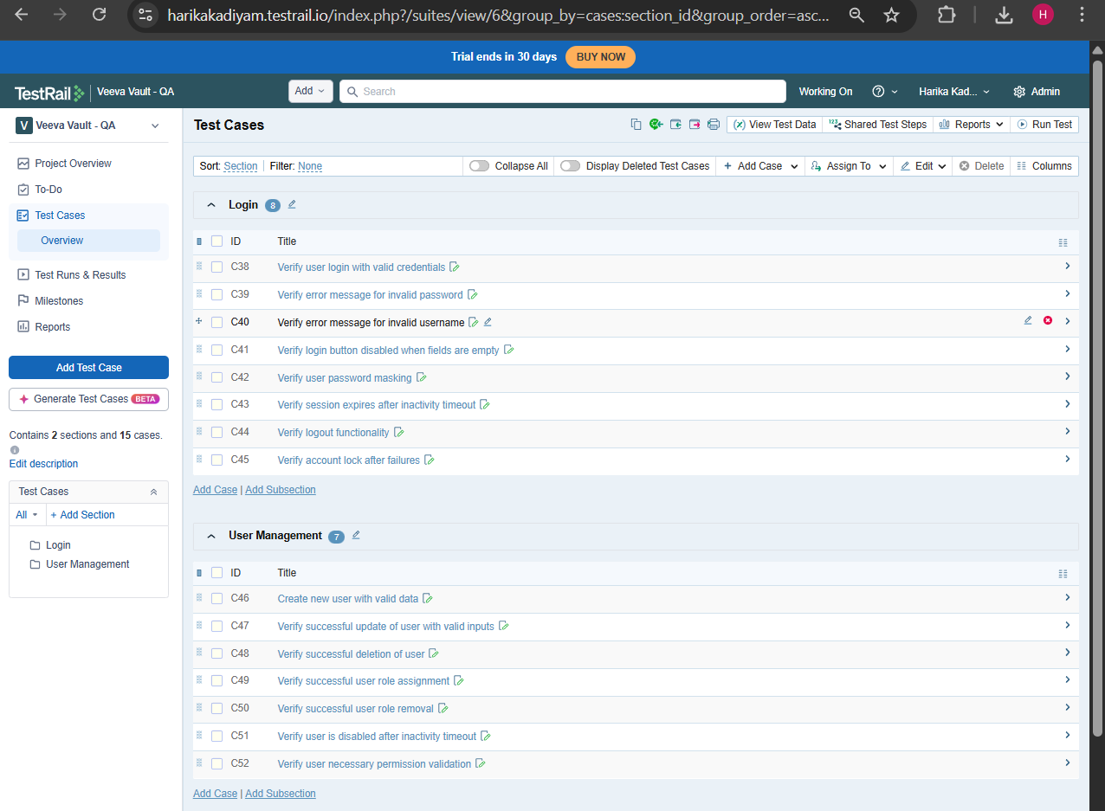
- Used:
  - Steps format
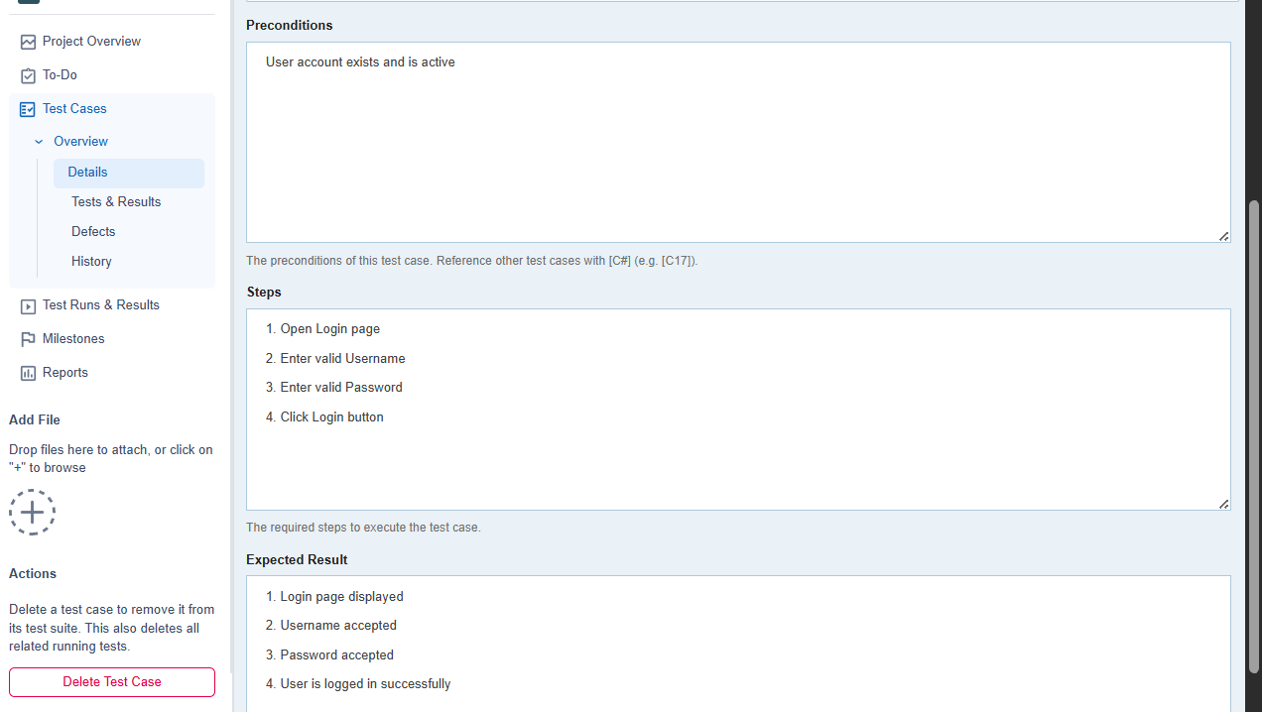

  - Priority levels
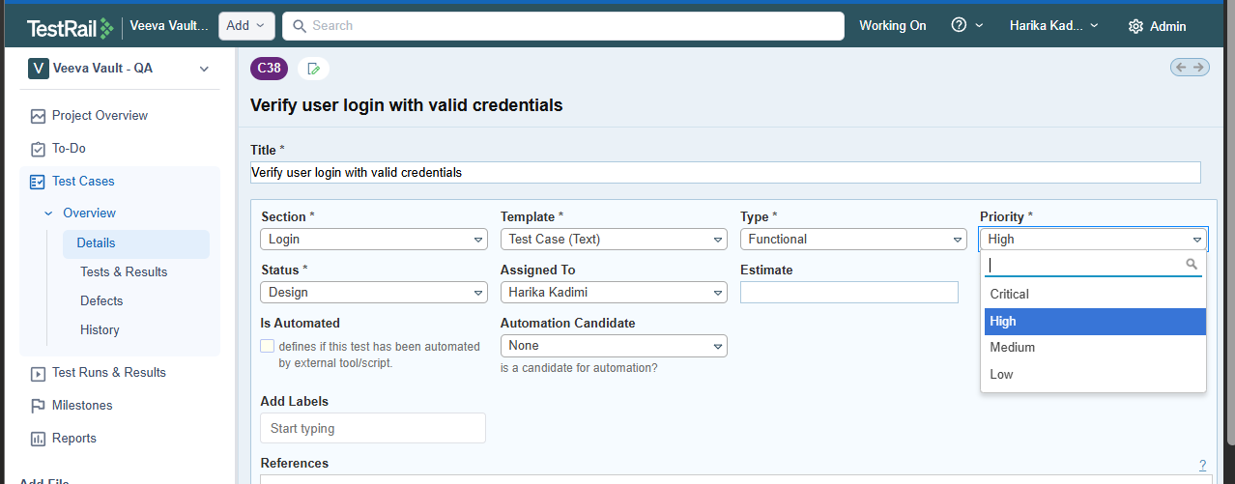
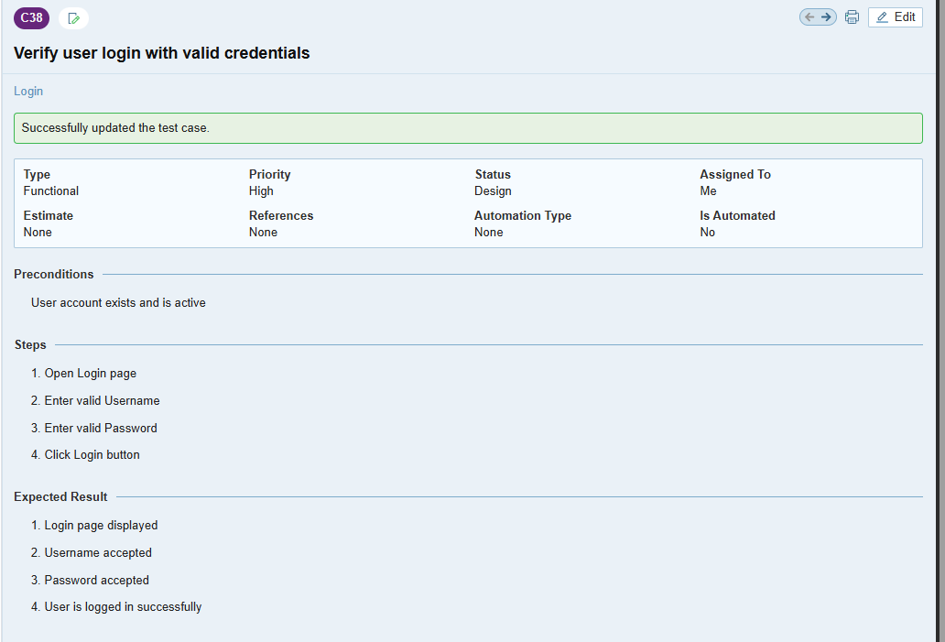
- Edited, cloned, and deleted test cases
- Edit option

- Before editing
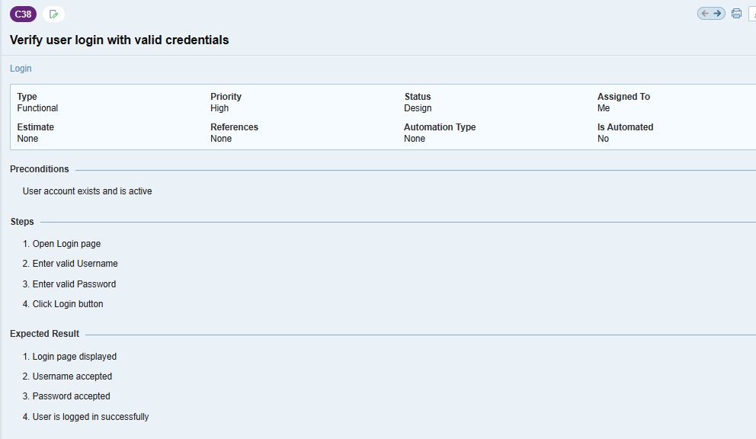
- After editing Priority and Expected Results
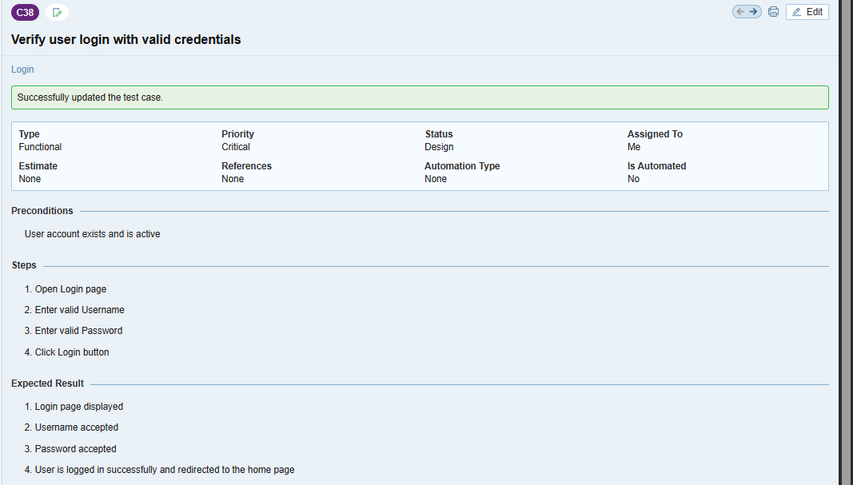
- Cloning a test case

Or
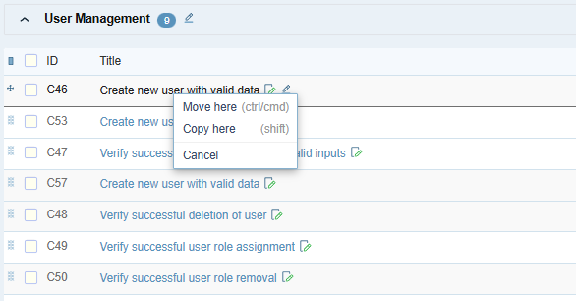
- After cloning
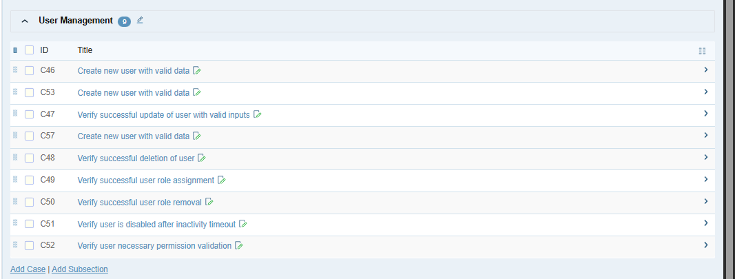
- After Updating
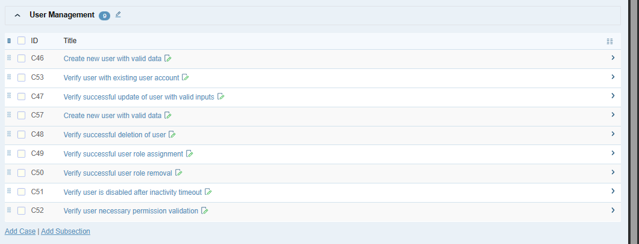

- Deleting the test case
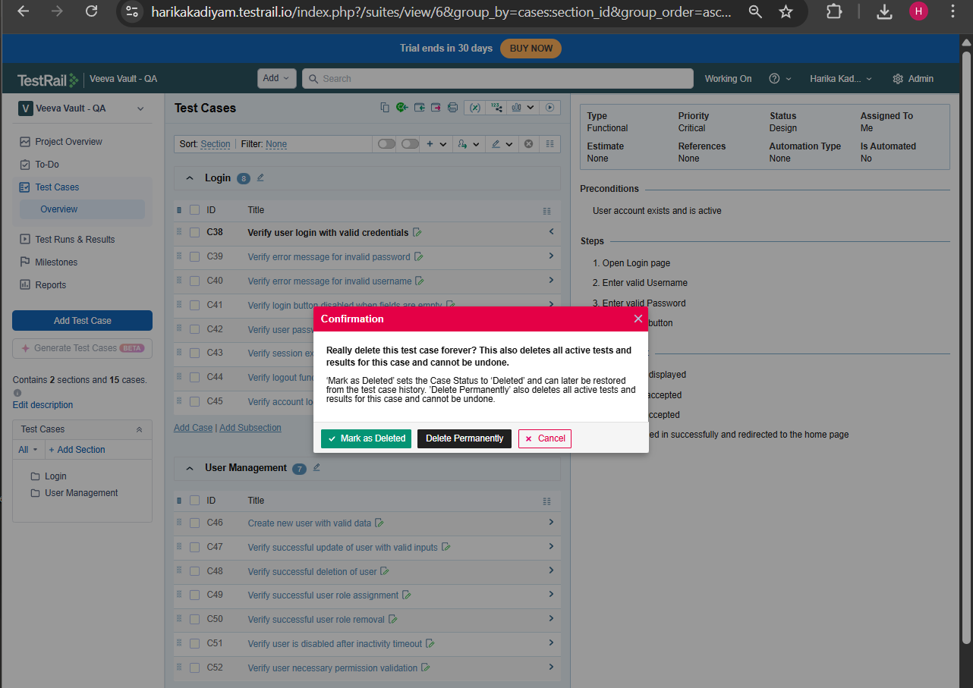

Day 3 : Test Runs & Execution
Learnt
- What a Test Run is
- Test statuses and meaning
- Difference:
  - Test Run vs Test Plan
Practical
- Created a Test Run
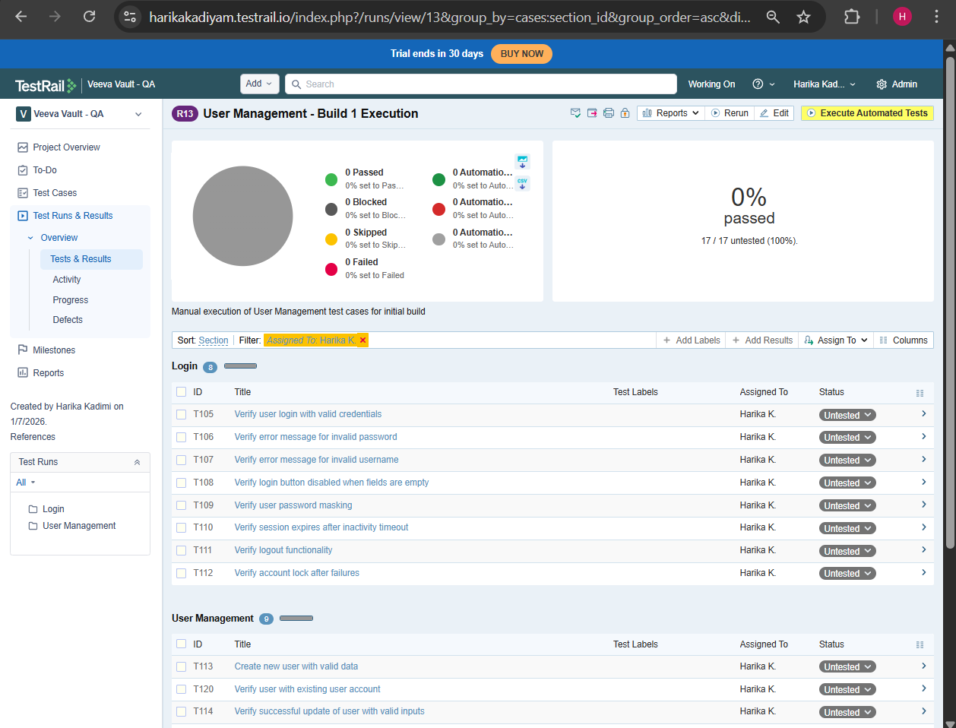
- Selected test cases from suites
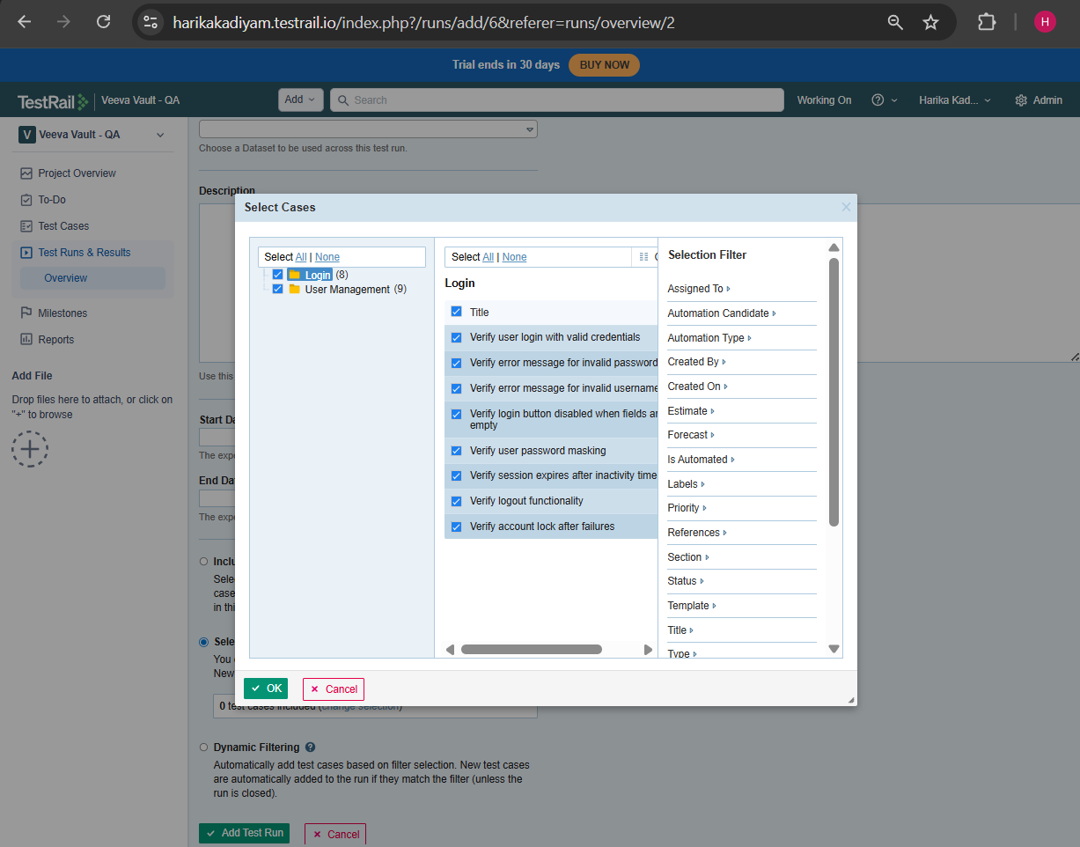
- Executed test cases:
  - Passed
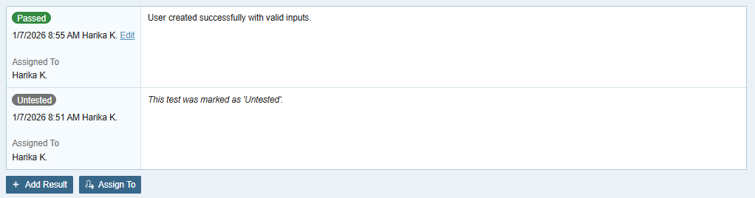
  - Failed
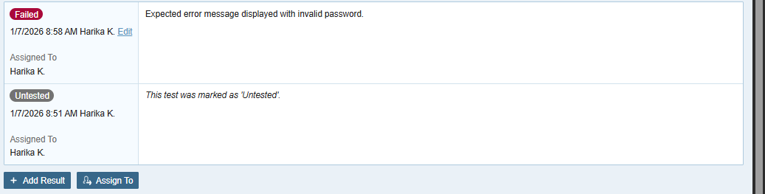
  - Blocked
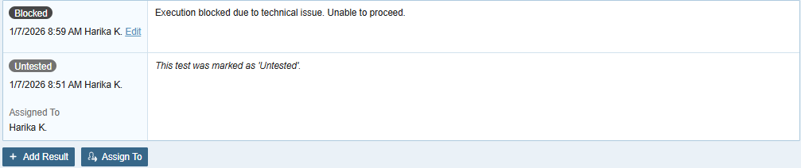
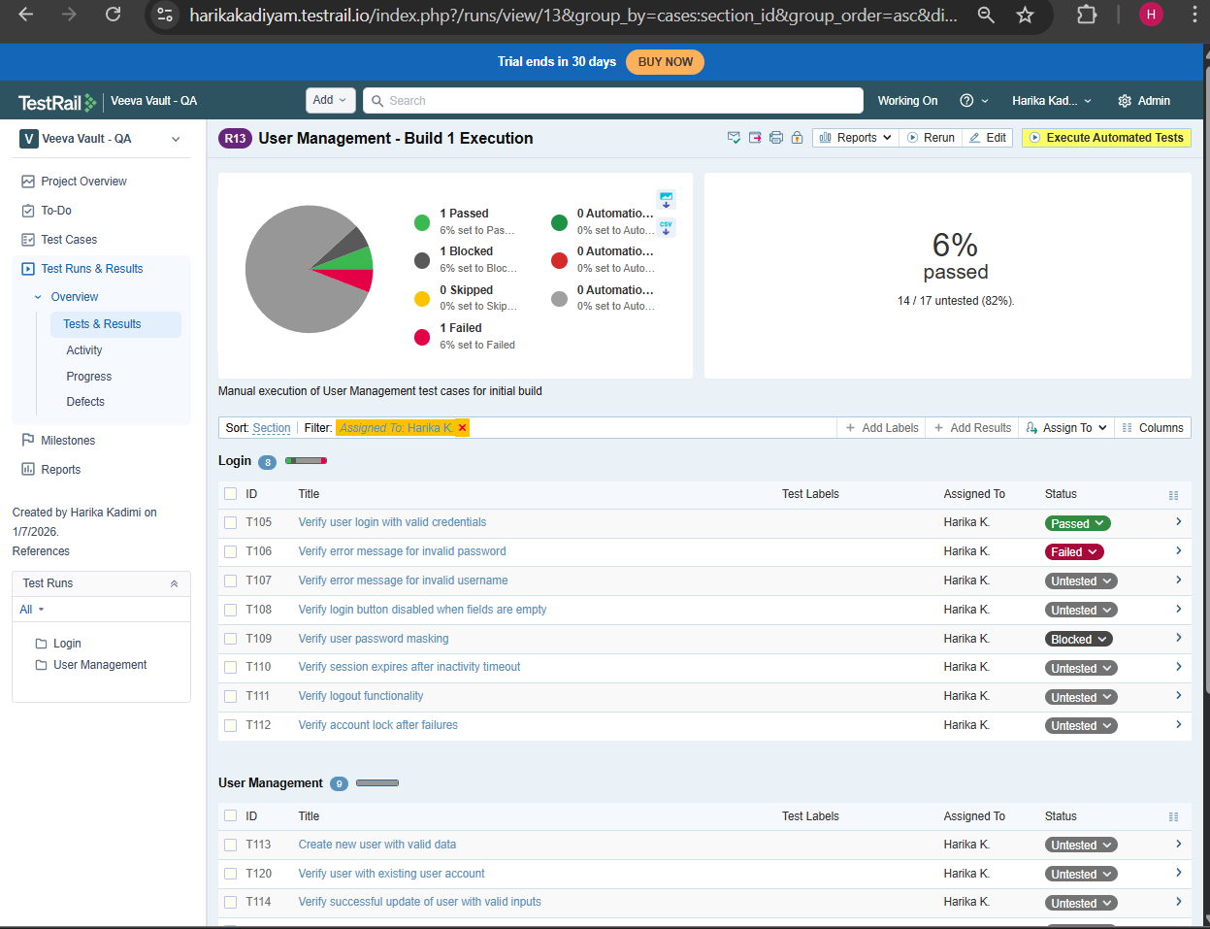
- Added execution comments
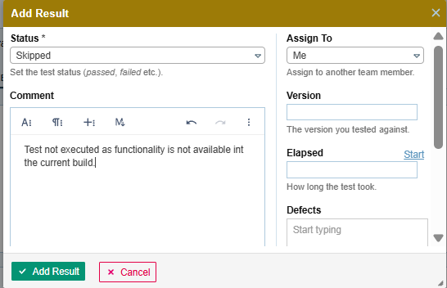

Day 4 : Defects & Traceability
Learnt
- Defect lifecycle
A defect (bug) is a deviation between expected and actual behavior discovered during test execution.
New → Open → In Progress → Fixed → Retest → Closed
↘
Rejected / Duplicate / Cannot Reproduce
- How TestRail handles traceability (Very Important)
TestRail does not manage requirements or defects natively. It links to Jira for both.
TestRail supports:
- Test Case -> Defect
- Test Run -> Defect
It does not support:
- Requirement -> Test Case (full RTM)
- Bi-Directional Traceability (by default)
This is why we call it Partial RTM.
- Limitations vs Xray
TestRail Limitation | Xray
External System: Operates separately from Jira, requiring integration for a unified workflow, which can feel fragmented. | Native Jira Integration: Turns tests into native Jira issues, offering seamless traceability and a single workflow.
Performance: Can experience slow performance and loading times with large test suites. | Performance: Can experience fast performance and loading times with large test suites.
Reporting: Reporting can be less powerful or cumbersome compared to Xray's native Jira JQL. | Reporting: Leverages Jira's JQL for powerful searching and reporting on test data.
BDD Support: TestRail does not have native Behaviour-Driven Development. | BDD Support: Superior native support for Behaviour-Driven Development (Gherkin syntax highlighting).

Practical
Without Integration -> TestRail shows the Bug ID as text
-> Jira has no idea this test exists
- Linked failed test cases to Jira bugs (or simulated)
Step 1: Create a Jira bug manually
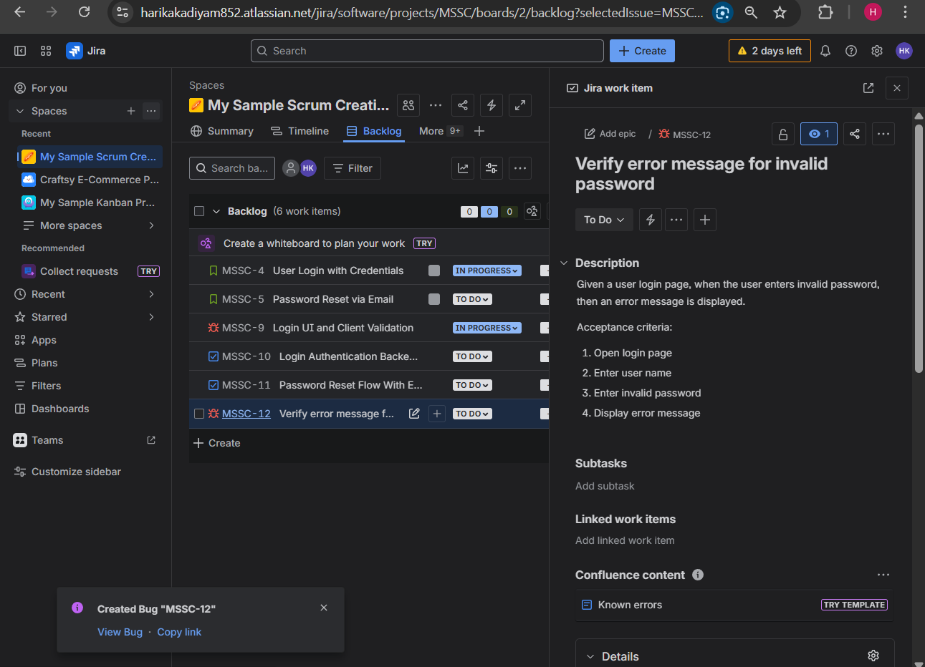
Step 2: Copy Bug ID
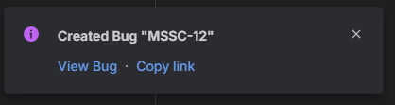
Example: https://harikakadiyam852.atlassian.net/browse/MSSC-12
Step 3: Go back to TestRail
Step 4: Click on Test Runs & Results
Step 5: Click on created Test Run
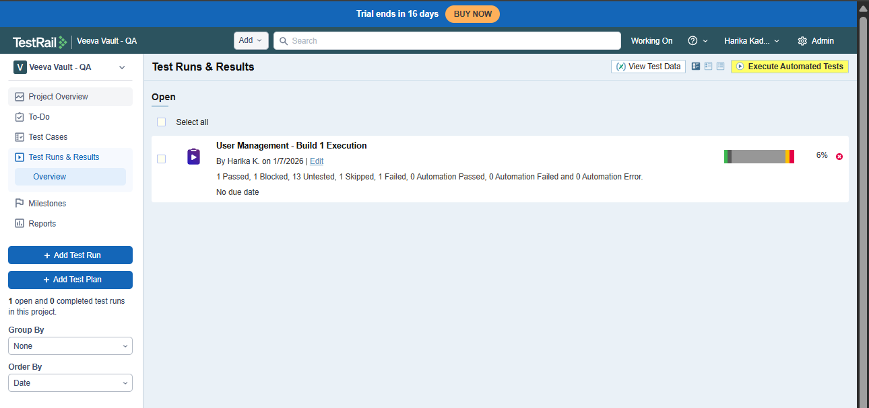
Step 6: Click on the failed test case
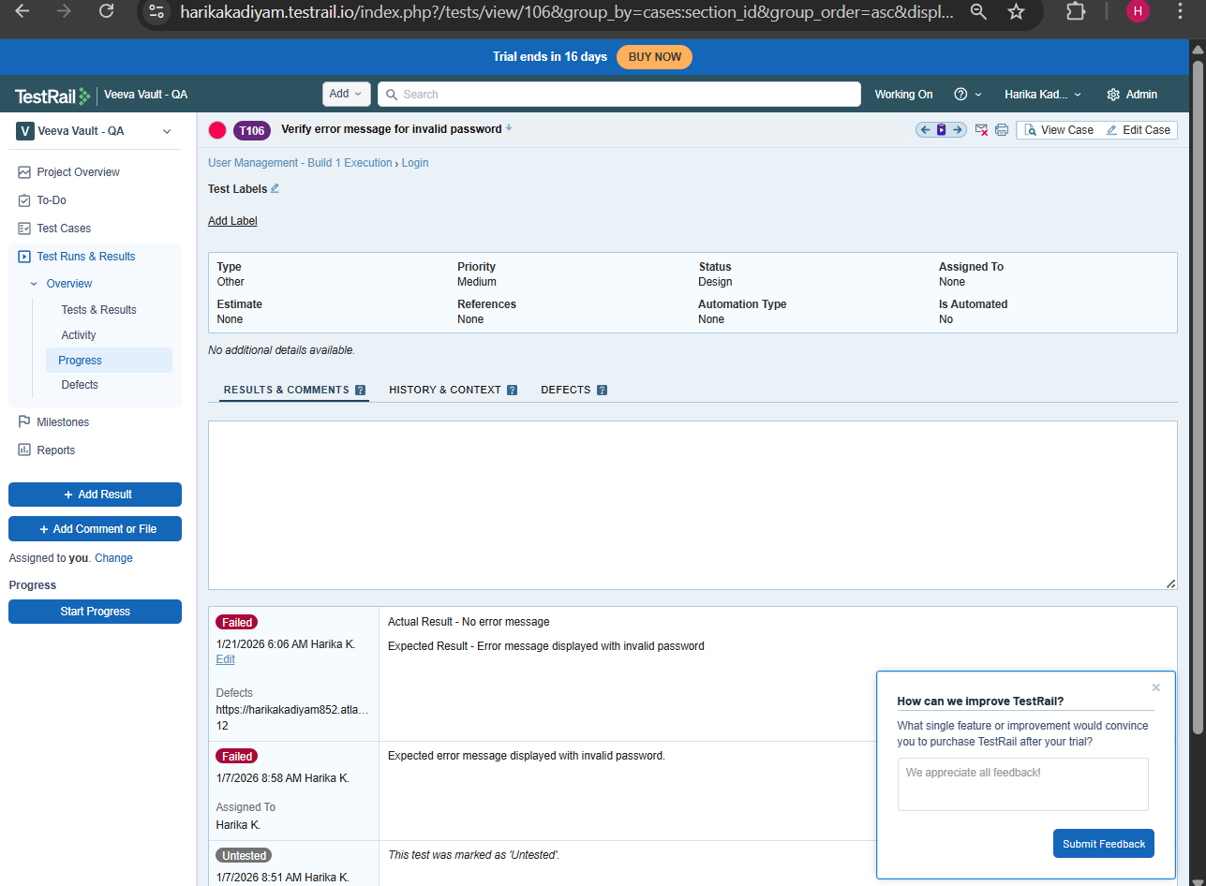
Step 7: Click on Add Result
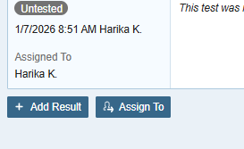
Step 8: Click on Defects field and copy the Bug ID, copied from Jira, then click on Add Result.
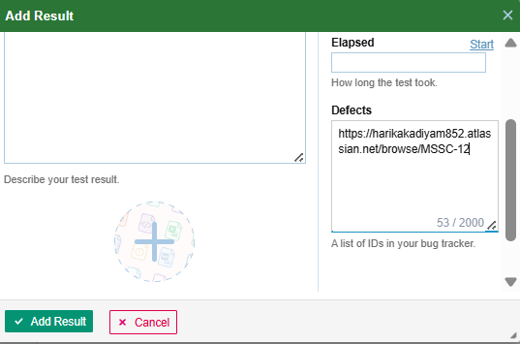
Now Jira defect is linked to the TestRail defect.
- Viewed defect references inside TestRail
Open Test Run
Click the failed test case
Scroll to Defects field

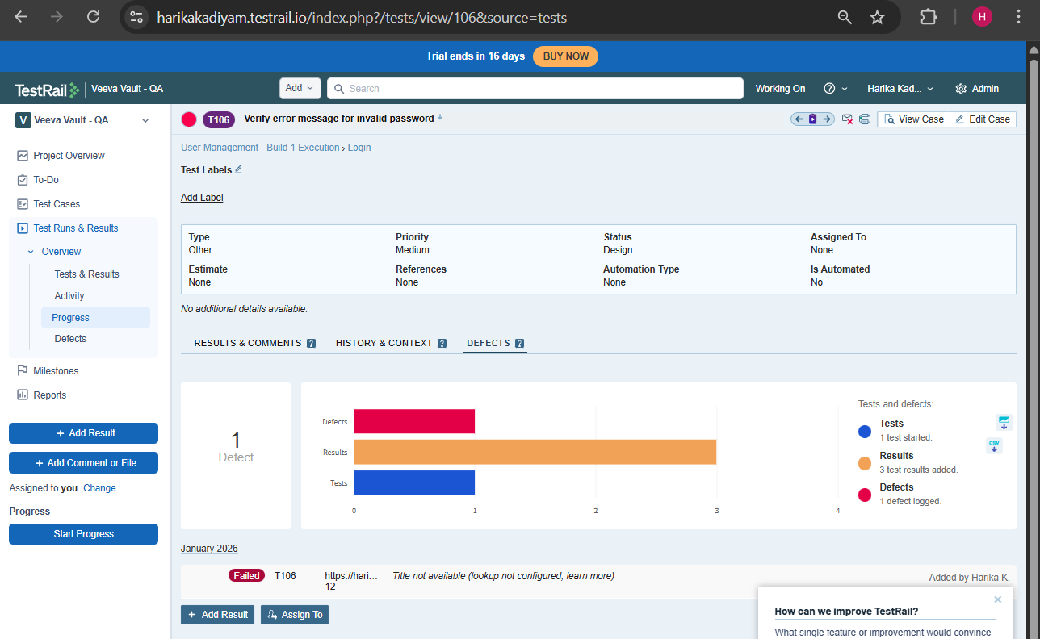
With Integration -> Bug appears in TestRail
->Test Execution link appears in jira
->No copy-paste
->No typo risk
Step1 : Click on Admin
Step2 : Go to Integration
Step3: In integrations tab click on Jira
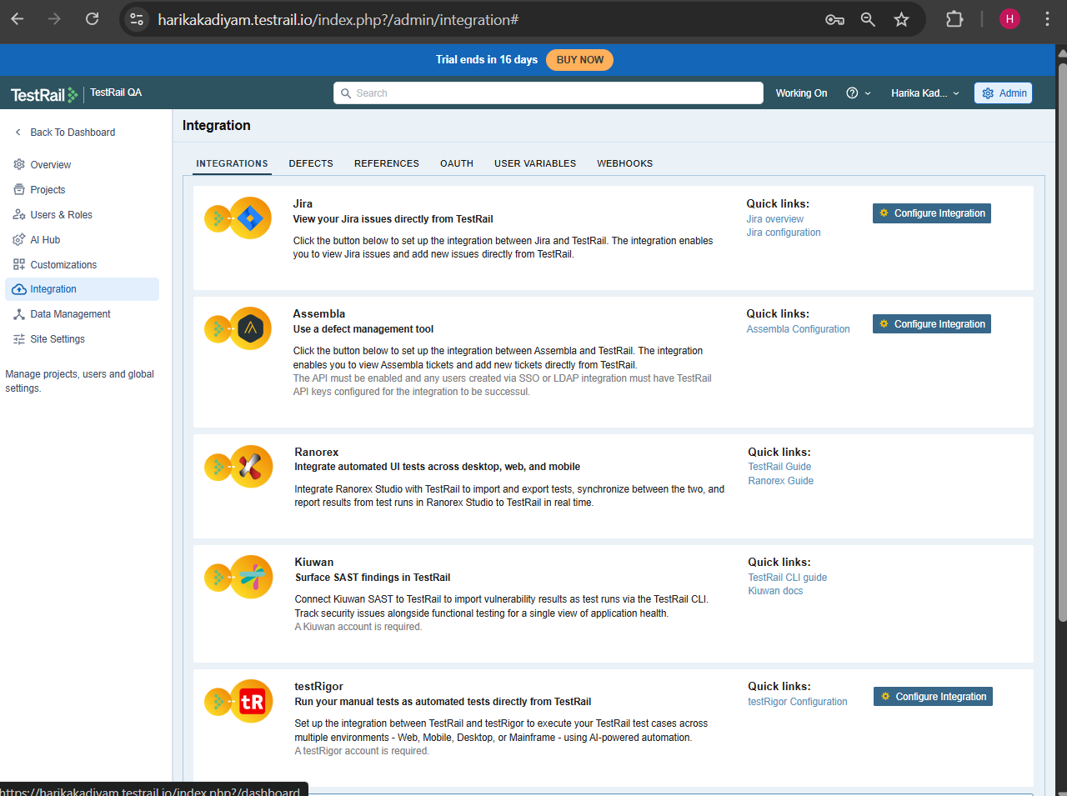
Step4: Click on configure Jira
Step5: Enter Jira Base URL. Example: https://harikakadiyam852.atlassian.net
Step6: Choose Jira Version, commonly jira cloud.
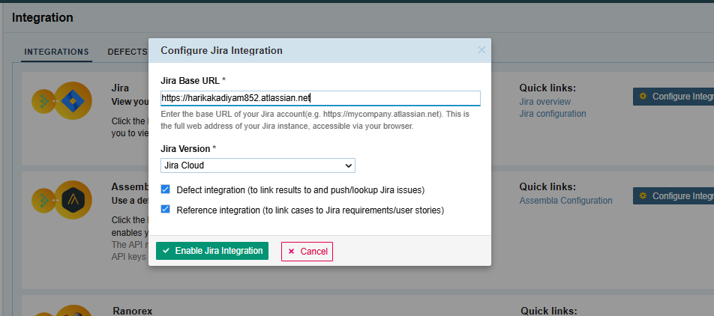
Then you are redirected to the below page for authentication.
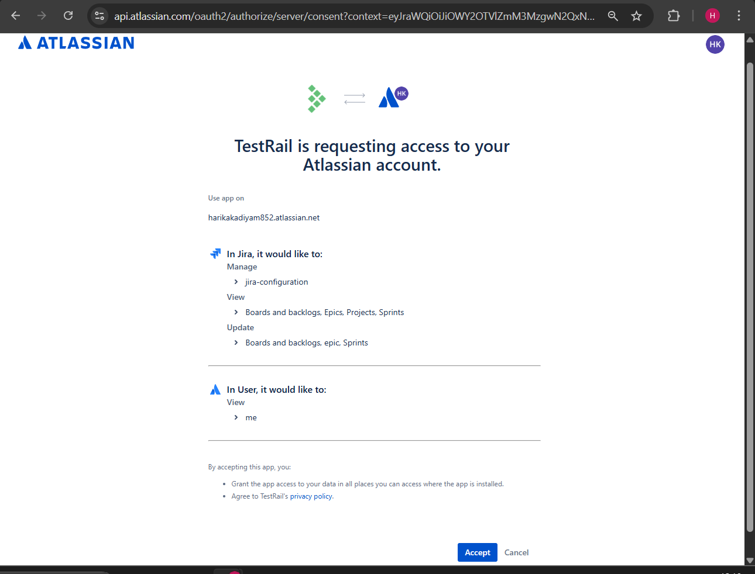
Integration successful.
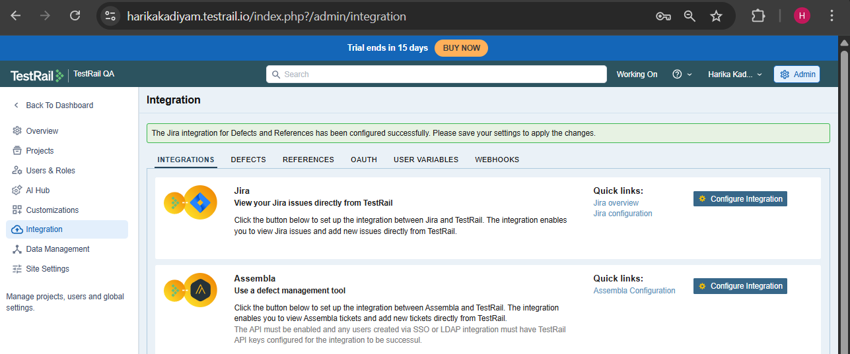
Click on save settings to save the configuration.
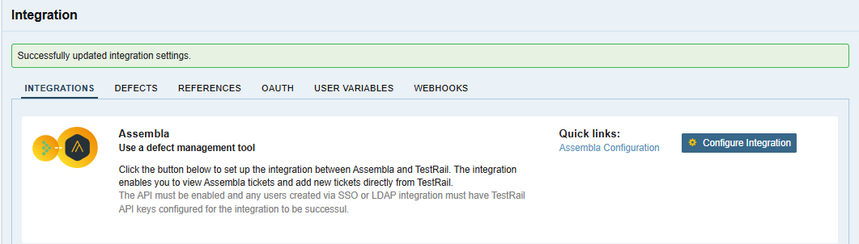
- Understood:
- Partial RTM in TestRail
  - What TestRail can trace:
Test Case → Test Run → Defect
  - What it cannot trace:
Requirement → Test Case → Defect

Session 2 – Release Management + Reports + Veeva Context

Day 5 : Test Plans & Release Testing
Learnt
- What is a Test Plan in TestRail
A Test Plan is a container for multiple test runs that together represent testing for one release or one sprint.
Release / Sprint → Test Plan → Multiple Test Runs
- Test Plan vs Test Run (clear difference)
Aspect | Test Plan | Test Run
Purpose | Release-level tracking | Execution-level tracking
Contains | Multiple test runs | Test cases
Used when | Multiple test types | Single execution cycle
Status | Overall release progress | Pass/Fail per test
Example | Sprint 1 Test Plan | Smoke Run

- Managing multiple runs per release
Project
└── Release (v1.2)
├── Test Plan
│ ├── Test Run – Smoke
│ ├── Test Run – Regression
│ └── Test Run – Integration
├── Test Run – Adhoc
└── Test Run – Hotfix Validation
In TestRail, a Release is a container, not an execution unit.
Within one Release, you can create:
- Multiple Test Plans
- Multiple Test Runs
- Multiple execution cycles
This allows parallel and iterative testing without duplicating test cases.

Practical
- Created Test Plan – Sprint 1 / Release 1
Step 1: Navigate
- Go to Test Runs & Results
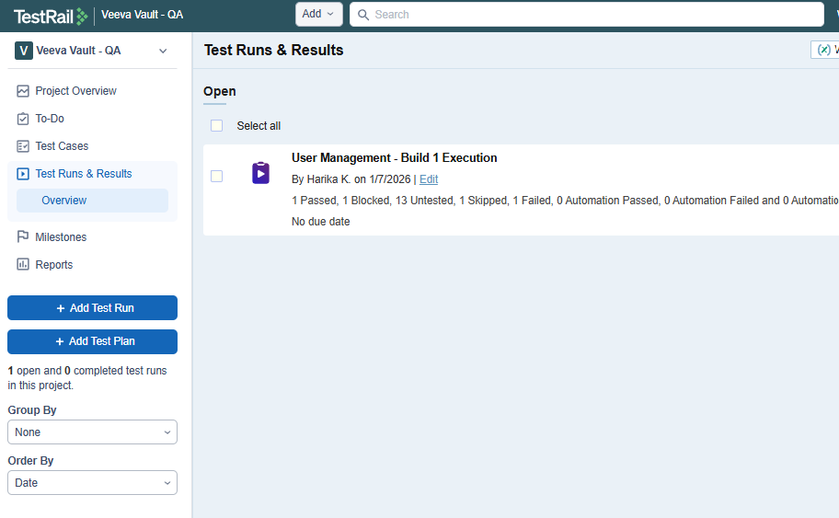
- Click Add Test Plan
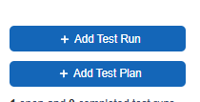
Step 2: Fill the Plan Details and click on Add Test Plan.
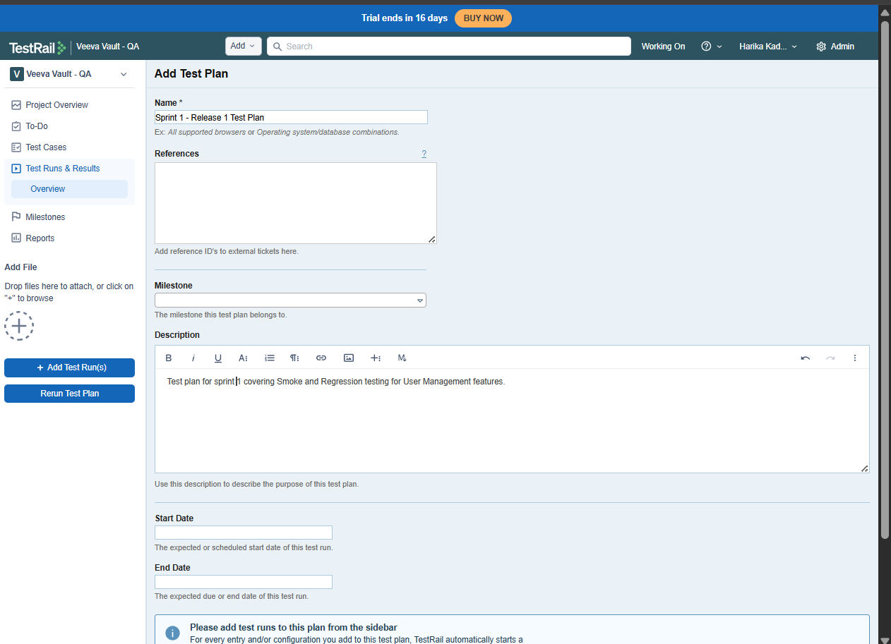
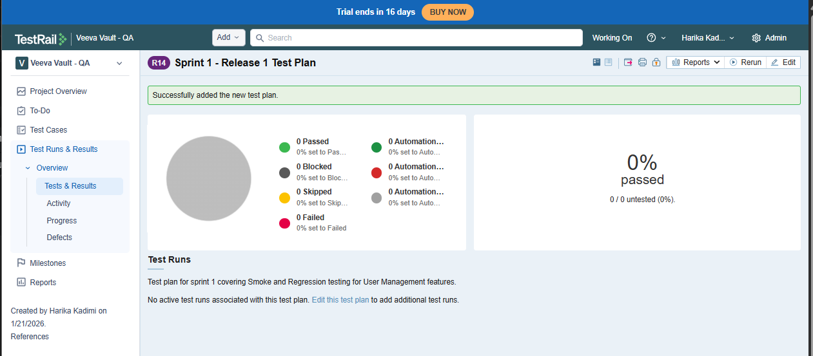
- Added multiple test runs:
  - Smoke - Smoke Testing is a shallow but critical validation performed on a new build to ensure that the core functionality is stable enough for further testing.
-> Is this build testable?
Run 1: Smoke Test Run
Step 1: Add Run
- Click Add Test Run
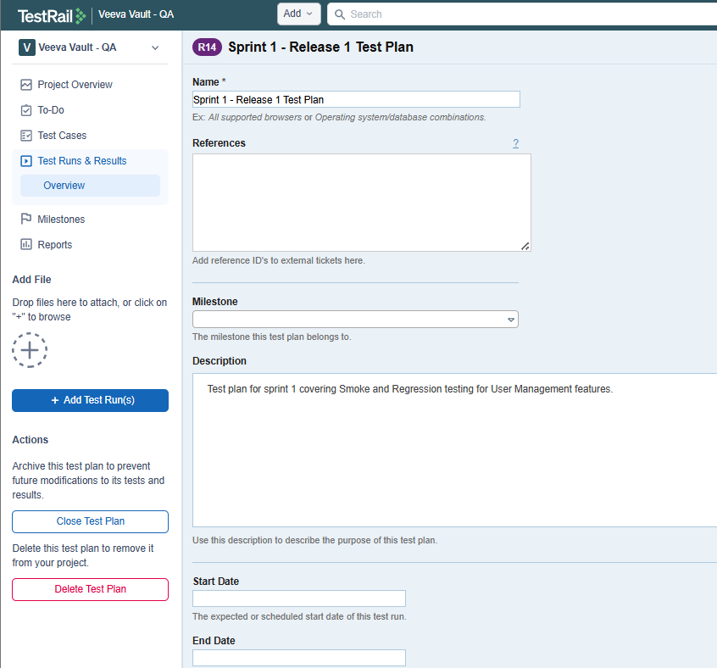
- Name:
Smoke Test – Sprint 1
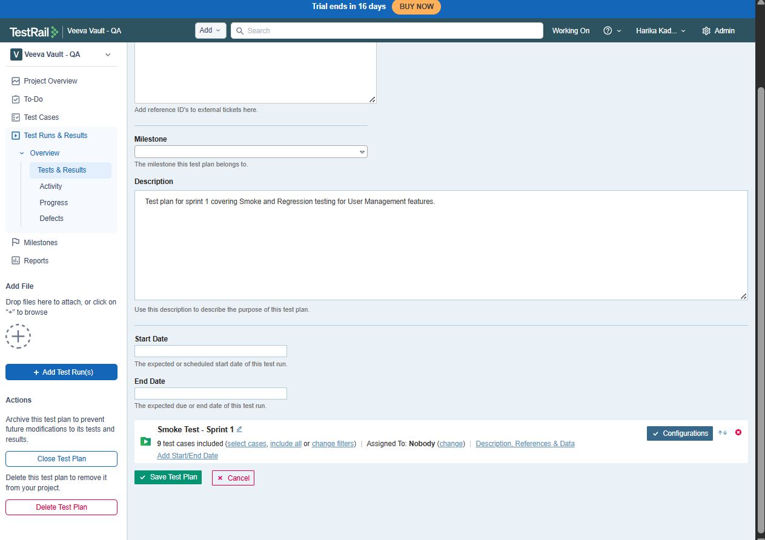
Step 2: Select Test Cases
- Choose:
  - Specific Smoke suite
OR
  - Filter using priority = High

Step 3: Assign
- Assigned To:
Yourself or team member
Click Add Test Run
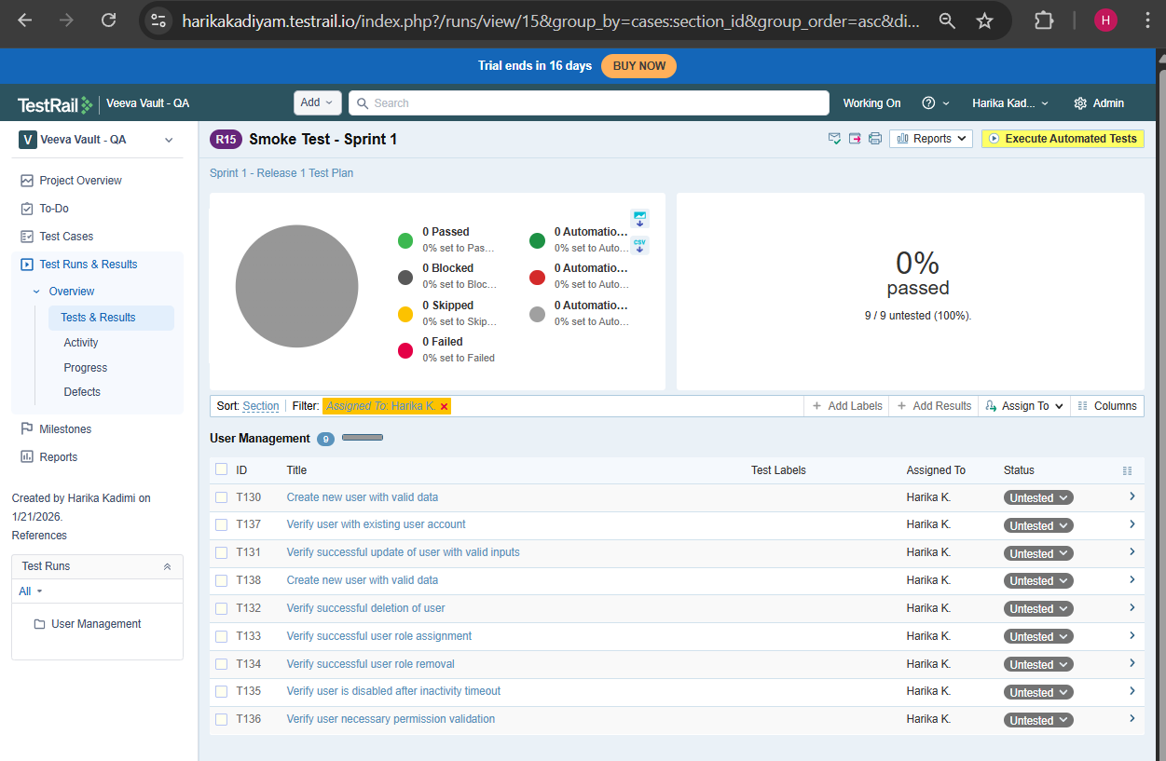

  - Regression - The primary purpose of regression testing is to ensure that recent code changes (like bug fixes, new features, or updates) haven't accidentally broken or negatively impacted existing, previously working functionality in a software application, acting as a safety net to maintain overall quality, stability, and reliability as the software evolves. It re-runs old tests to catch unintended side effects, ensuring that progress doesn't compromise core features like login, checkout, or other critical workflows.
  - Regression Test Run
  - Example: Regression Test Sprint 1
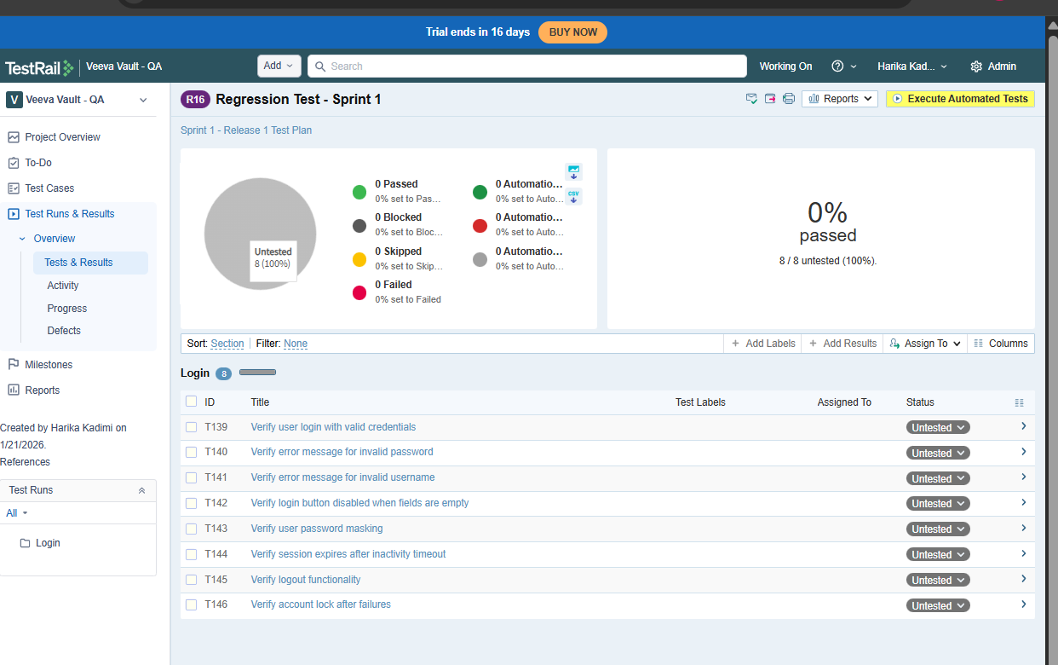
- Assigned test runs (Very Imp)
- Open a test run
- Select test cases
- Click assign to
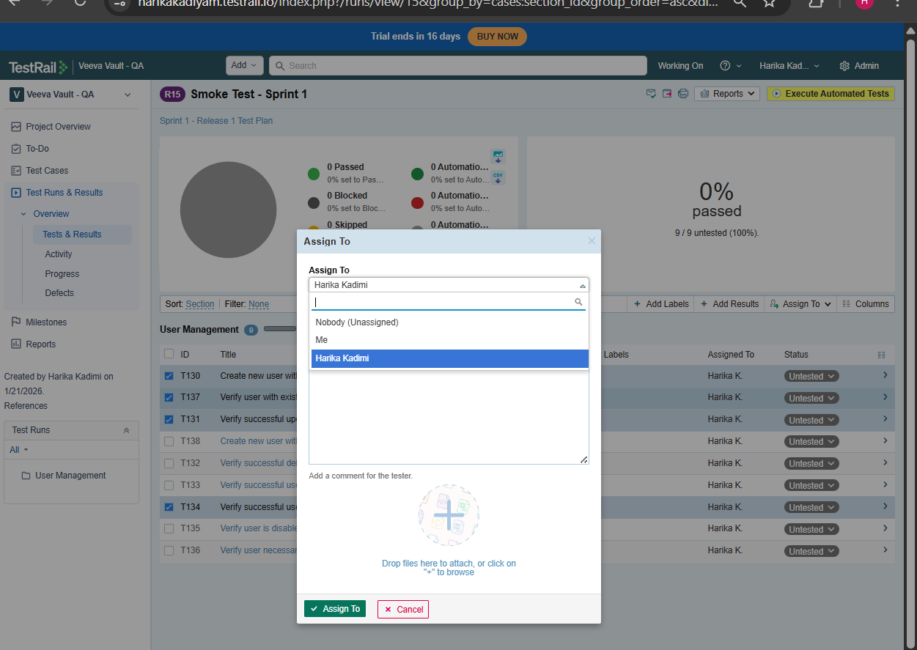
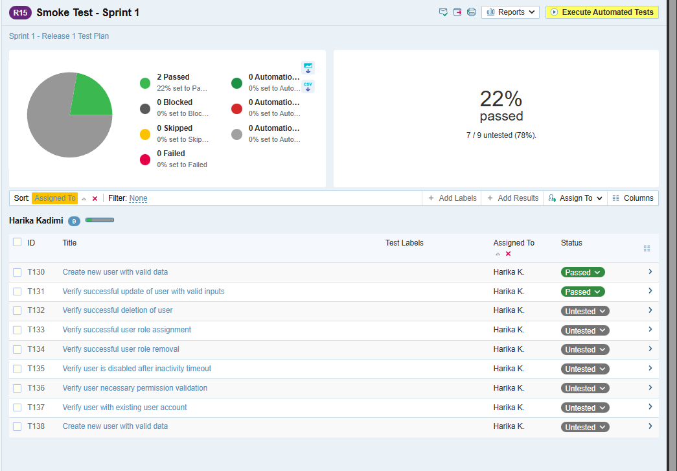
- Tracked execution progress
- Open any test run
- Mark test cases as:
- Pass
- Fail
- Blocked
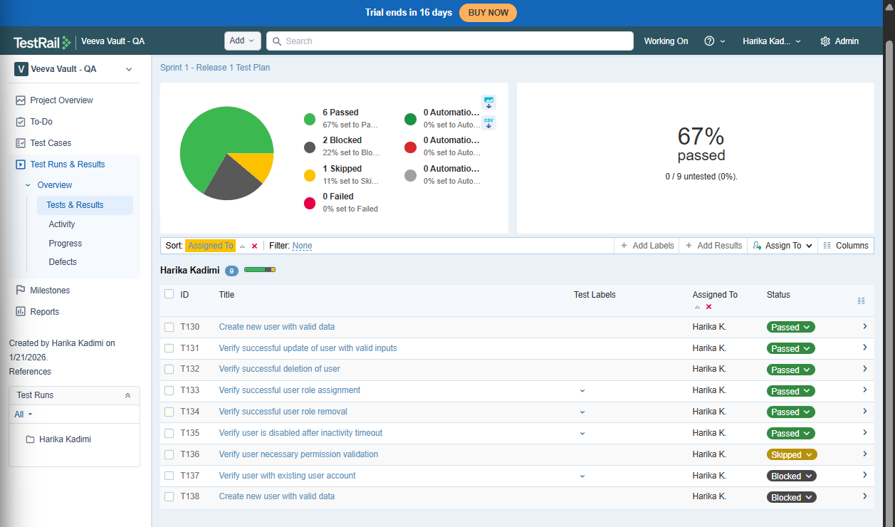

Day 5 : Reports & Metrics (Veeva-Critical) (2 Hours)
Learnt
- TestRail reporting capabilities
TestRail can generate:
- Execution status reports
- Defect-related reports
- Historical trend reports
- Audit-friendly exports
Reports can be:
- Project-level
- Milestone-level
- Test Plan / Test Run-level
- Key reports:
  - Test Summary - How much testing is completed and what is the overall quality?
Shows:
- Total test cases
- Passed / Failed / Blocked
- Completion %
  - Results by Status - Exactly how many tests are in each execution state?
Shows:
- Passed
- Failed
- Blocked
- Untested
- Retest
  - Defect Summary - What quality risks remain?
Shows:
- Number of failed tests
- Linked defects (if integration exists)
- Failure trends
⚠️ Even without Jira integration, this report is still used.
- Audit & compliance importance
Requirement → Test Case → Execution → Defect → Release Sign-off
- Versioned test cases
- Execution history per release
- Comments and attachments
- User-based execution logs
- Limited electronic signature support (tool + process)

Practical
- Generated execution reports
Steps:
- Go to Reports
- Select Defects Summary
- Scope:
  - Test Run or Test Plan
- Generate
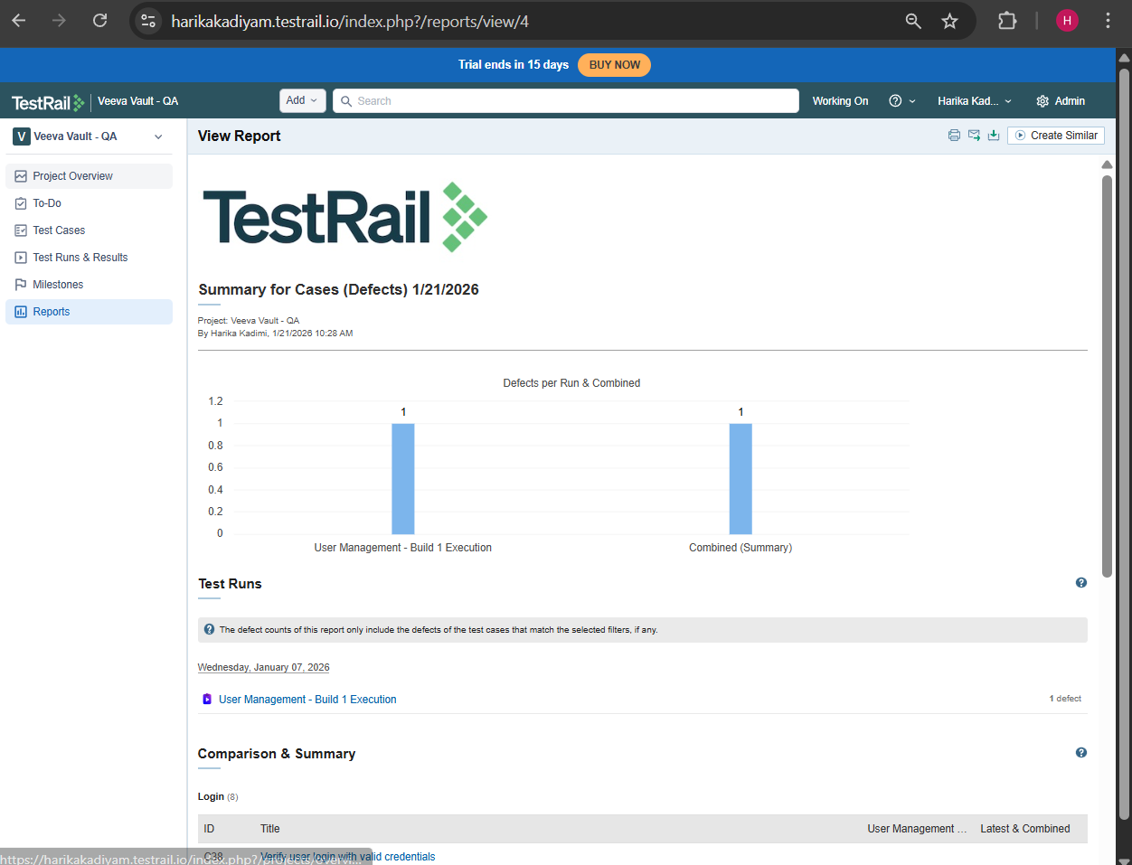
- Exported reports (PDF / HTML)

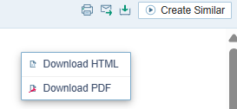
- Reviewed historical data
Steps:
- Generate same report
- Change:
  - Milestone
  - Date range
- Compare pass % / fail %
Why auditors care
- Shows process consistency
- Shows quality improvement
- Detects repeated failures

Day 6 : Advanced Concepts + Comparison (1.5 Hours)
Learnt
- TestRail vs Xray – deep comparison
- When TestRail should NOT be used
Situation | Reason
Regulated GxP projects | Weak native traceability
Jira-first organizations | Context switching
Audit-heavy environments | Mutable evidence
Single system mandate | Fragmented tooling

- Why Veeva prefers Xray + Jira
  - Jira is the System of Record
  - Native Requirement Traceability
  - GXP Compliance Support
  - Single Tool, Single Evidence Chain
  - Reduced Validation Effort
Practical
- Mapped:
  - User Story → Test → Execution → Defect
- Identified traceability gaps

Day 6 : Interview Prep & Final Flow (1.5 Hours)
Practical
- Created full workflow:
  - Test Cases
  - Test Plan
  - Test Run
  - Execution
  - Defect
  - Report
- Prepared answers for:
  - “How do you manage releases in TestRail?”
  - “How do you ensure traceability?”
  - “TestRail vs Xray?”

